This summer
You had FUN trying SCOTTISH COUNTRY DANCING
at STANLEY PARK on a Monday night

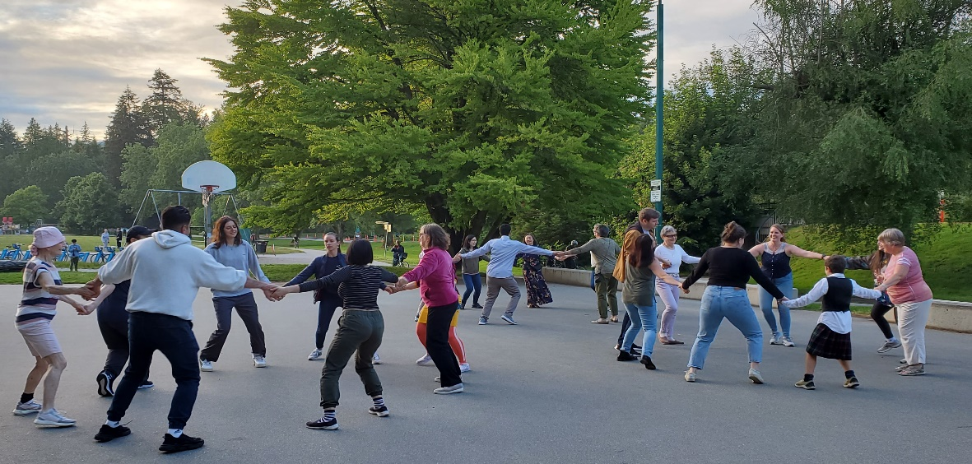
Join us again for some more DANCING FUN, still FREE!
Monday August 29, 2022 7:00–8:45PM
Indoors at the WEST END COMMUNITY CENTRE
876 Denman Street

Preregister at: http://ca.apm.activecommunities.com/vancouver/Activity_Search/423205
Or come early and register on the night

No partner, no experience, no kilt required, For more information:
Light weight clothes and soft shoes are good. Alison: ditp@rscdsvancouver.org
Bring your friends – ages 17+ Duncan: ceilidh@rscdsvancouver.org
Bring your own water bottle

EVERYONE IS WELCOME
Dancing led by RSCDSVancouver.org

